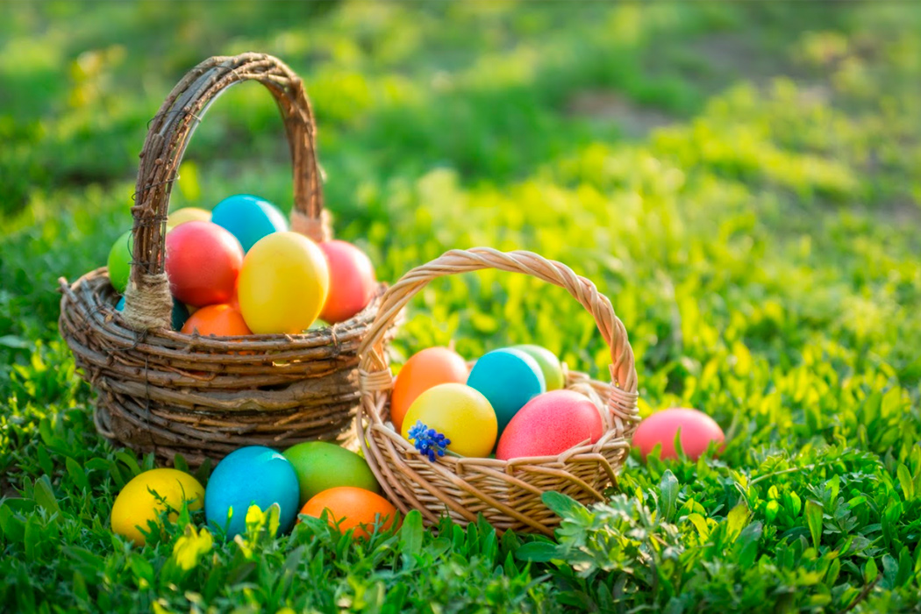

Outdoor Activities

* Have an Easter egg hunt! Ask a grown-up to hide some Easter eggs for you to find.
* How many eggs can you find? Or hold on inside if the weather is not good here are some clues you might like to use

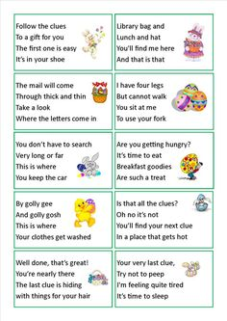

* Ideas here…
* Draw an egg shape and then put a number 1to 10 at the top let the children put the correct number of objects on the egg



Make little nests out of brown paper and count the correct number of chicks/eggs into them. Maybe find out how many chicks /eggs are in two nest by counting them altogether,

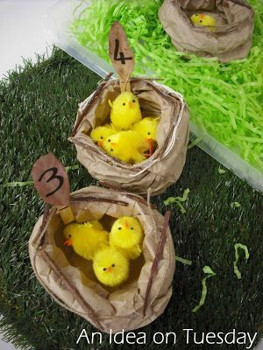

Any other ideas…Play pin the tail on the rabbit or roll the egg into hunger rabbit and count how many eggs he has eaten at the end of the game

* Ideas here… how about printing some bunnies using tubes, or decorate some eggs by finding different things to print with. Make a sponge template of a chick/bunny/carrot or egg and print with it

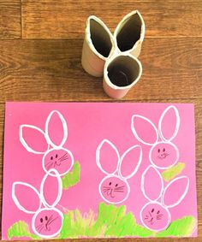  

or you could do some Easter threading. 

Decorate some hard-boiled eggs, to make them bright and colourful. You could use pens or paint and add some extra decorations, such as stickers, feathers, pom-poms

Easter Crafts

EYFS